# Project 3 ReadMe

## Team members:

Isabel Laurenceau 7393-5064

Anshika Saxena 9530-5566

## What is working:

## What is the largest network you managed to deal with:

Input: The input provided (as command line to your program will be of the form: mix run project3.exs numNodes numRequests

Where numNodes is the number of peers to be created in the peer to peer system and numRequests the number of requests each peer has to make. When all peers performed that many requests, the program can exit. Each peer should send a request/second.

Output: Print the maximum number of hops (node connections) that must be traversed for all requests for all nodes.

## Program- High Level : (To-Do In Red)

**Main**

Read input arguments

**MAINPROJ**

Start Supervisor

Create number of nodes

Create overlay network

Send first request from every node

**TAPESTRY**

Init Supervisor

**TAPNODE**

State

Get created

addToTapestry()

contactGatewayNode()

routeToObject (OG)

updateYourNeighborMap()

sendHello(new_neighbor, N)

receiveHello(new_neighbor, N)

sendNeighborMap(new_neighbor, N)

optimizeNeighborMap()

lookupNeighborMap()

notifyNeighbors(surrogate(new_id))

notifyEmpties()

nextHop(n, G)

sendFirst(childPid, *numRequestToSend* )

publishObject(OG)

unpublishObject(OG)

routeNode(N, Exact)

## Program- Pseudocode:

**Main**

Read input arguments{

Take command line arguments

Make them into integers

Pass the integers to MAINPROJ

}

**MAINPROJ**

Start Supervisor {

{:ok, _pid} = Tapestry.start_link(1)

}

Create number of nodes{

rng = Range.new(1, numNodes)

for x <- rng do

Tapestry.start_child(x, numRequests, neighbor_map)

end

}

Create overlay network{

for every child in Tapestry.whichchildren do

TAPNODE. AddToTapestry (childPid)

end

}

Send first request from every node{

for every child in Tapestry.whichchildren do

TAPNODE.sendFirst(childPid, *numRequestToSend* )

end

}

**TAPESTRY**

Init Supervisor

**TAPNODE**

State**{**

*new_id*

*numRequestToSend*

neighborMap - Routing Table

ROUTER -? processes routing and location messages

DYNAMIC_NODE_MANAGEMENT -? Handles arrival and departure of nodes

**}**

Pseudocode from Tapestry: An Infrastructure for Fault-tolerant Wide-area Location and Routing

**Get created {**

def init(*numRequestToSend*){

* Node *N* requests a new ID *new_id*
  + *new_id* = SHA-1(….?)
* *numRequestToSend = numRequestToSend*
* neighborMap = empty list
* ROUTER = ??
* DYNAMIC_NODE_MANAGEMENT == ?

}

def start_link(*numRequestToSend*){}

}

addToTapestry{

* Call contactGatewayNode(); returns G
* H = G;
* For (i=0; H != NULL; i++) {
  + Grab ith level NeighborMap_i from H;
  + For (j=0; j<baseofID; j++) {
    - //Fill in jth level of neighbor map
    - Call updateYourNeighborMap()
    - While (Dist(N, NM_i(j, neigh)) > min(eachDist(N, NM_i(j, sec.neigh)))) {
      * neigh=sec.neighbor;
      * sec.neighbors=neigh−>sec.neighbors(i,j);
    - }
  + }
  + H = NextHop(i+1, new_id);
* } //terminate when null entry found
  + - Route to current surrogate via new_id;
    - Move relevant pointers off current surrogate;
    - Call notifyNeighbors(surrogate(new_id))

}

contactGatewayNode(){

* + - Call routeToObject (OG) ; Use routing algorithm to find G as if N was an object
    - Returns Node G

}

routeToObject(OG) {

* Return root node of where object is (or would be) located
* Uses nextHop function?
* “A route to a non-existent identifier will encounter empty neighbor entries at various positions along the way. In these cases, the goal is to select an existing link which acts as an alternative to the desired link (i.e. the one associated with a digit of I). This selection is done with a deterministic selection among existing neighbor pointers. Routing terminates when a neighbor map is reached where the only non-empty entry belongs to the current node. That node is then designated as the surrogate root for the object.”

}

updateYourNeighborMap{

For (i=0;i<digits && H(i) !=NULL;){

1. Send Hello(i) to H(i)
2. Send NeighborMap’(i)
3. NM(i) = Optimize N.M.’(i)
4. Hi + 1 = LookupNM(N, i+1)
5. H = Hi+1

}

“After repeating this process for each entry, we have a near optimal neighbor map. The neighbor map population phase requires each neighbor map to be optimized in this manner until there are no nodes to put in the map, due to network sparsity.

The new node stops copying neighbor maps when a neighbor map lookup shows an empty entry in the next hop. It then routes to the current surrogate for *new_id*, and moves data meant for *new _id* to *N*.

}

sendHello(new_neighbor, N){

Node N sends hello to Neighbor new_neighbor H(i)

}

receiveHello(new_neighbor, N){

* SendNeighborMap()
* “When we proceed to fill in an empty entry at *N*, we know from our algorithm the range of objects whose surrogate route were moved from” [N+1 entry location]
* “We can then explicitly delete those entries”
* “republish those objects”
* “establishing new surrogate routes which account for the new inserted node.”

}

sendNeighborMap(new_neighbor, N){

Neighbor new_neighbor sends its neighbor map to Node N

}

optimizeNeighborMap(){

“Optimizing means comparing distances between N and each neighbor entry and its secondary neighbors. For any given entry, if a secondary neighbor is closer than the primary neighbor, then it becomes the primary neighbor”

* N calls LookupNeighborMap()

}

LookupNeighborMap() {

“Looks up nodes in its neighbors’ neighbor maps, and compares its distance to each of them to determine if they are better potential neighbors. This optimization repeats until no significant improvement can be made by looking for further neighbors.”

}

notifyNeighbors(surrogate(new_id)){

Purpose: notifies nodes who have an empty entries where *N* should be filled in

* Call notifyEmpties();
* for all neighbors and secondary neighbors in each level
  + Call Hello() ;

**}**

notifyEmpties(){

Purpose: “Use surrogate(new_id) backptrs to notify nodes by flooding back levels to where surrogate routing first became necessary.

* traverse the surrogate’s backpointers back level by level to the level where surrogate routing first became necessary.
  + Call Hello()

}

publishObject (OG) {

* Publish, or make available, object on the local node. This call is best effort, and receives no confirmation.
* A server , storing an object O (with GUID OG , and root OR3), periodically advertises or publishes this object by routing a publish message toward OR.
* In general, the nodeID of OR is different from OG, OR is the unique [2] node reached through surrogate routing by successive calls to NEXTHOP(*, OG).
* Each node along the publication path stores a pointer mapping, < OG , S> , instead of a copy of the object itself. When there are replicas of an object on separate servers, each server publishes its copy.
* Tapestry nodes store location mappings for object replicas in sorted order of network latency from themselves.
* A client O locates by routing a message to OR. Each node on the path checks whether it has a location mapping for O.
  + If so, it redirects the message to S.
  + Otherwise, it forwards the message onwards to OR (guaranteed to have a location mapping).

}

unPublishObject (OG) {

Best-effort attempt to remove location mappings for O.

}

routeToNode (N, Exact):{

Route message to application Aid on node N. “Exact” specifies whether destination ID needs to be matched exactly to deliver payload

}

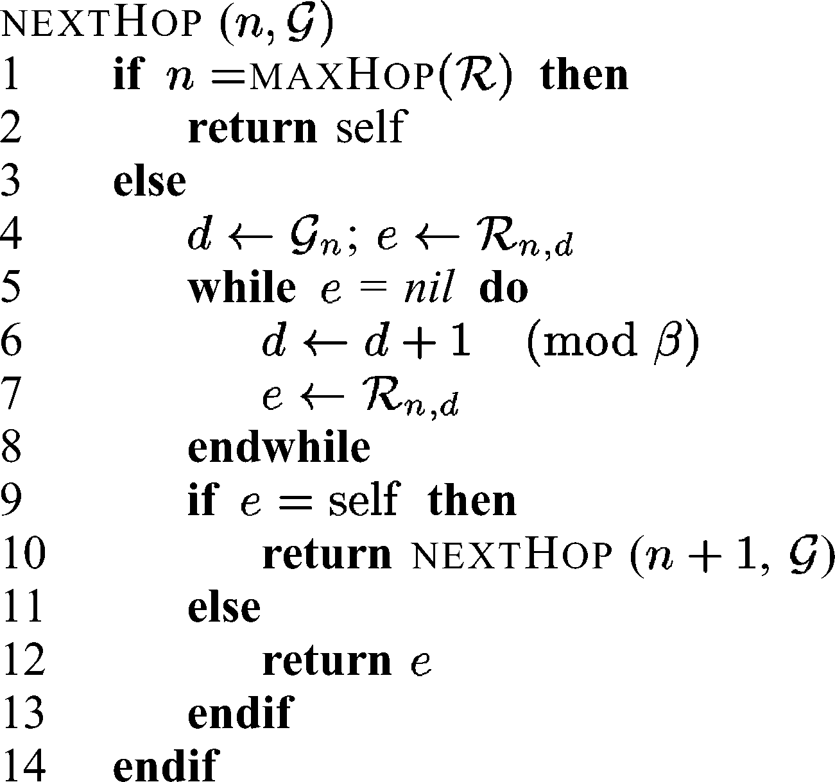nextHop(n,G){

}

sendFirst(childPid, *numRequestToSend* ){

send request to

…

new*numRequestToSend = numRequestToSend – 1*

PUBLISHOBJECT(OG, Aid)

Wait one second

sendFirst(childPid, *newnumRequestToSend* )

}